Wavemaker Manual

by Matthias Page

University of New Hampshire

Chase 185

**Table of Contents:**

**Daily Operation**

* Mechanical………………………………………………………………………………………………………….…………3
  + Positioning the Wavemaker (Pg. 3)
  + Getting Ready to Run (Pg. 4)
* Software………………………………………………………………………………………………….…………………….4
  + Computer (Pg. 5)
  + Making Waves (Pg. 5-7)
  + Common Issues (Pg. 7)

**Initial Setup**

* Mechanical Setup.……………………………………………………………………………………………..………..…8
  + Belt (Pg. 8-9)
  + Wedge (Pg. 10-11)
  + Electronics Shelf (Pg. 11)
  + Electronic (Pg. 12-13)
  + Limit Calibration (Pg. 14)
* Software Setup.……………………………………………………………………………………..…………………….14
  + Arduino (Pg. 14-15)
  + Libraries (Pg. 15)
  + Firmware Integration (Pg. 15-16)

**Maintenance**

* Per-Operation Maintenance……………………………………………………………………………………..….17
  + Belt Tension (Pg. 17)
  + Rotary Encoder Engagement (Pg. 17)
  + Wiring Connections (Pg. 18-19)
  + Switch Triggering (Pg. 20)
  + Panic Button (Pg. 20)
* Weekly Maintenance……………………………………………………………………………………………….…..21
  + Recoating Wedge [TREAT WEDGE] (Pg. 21)
  + Cleaning Water [CLEAN WATER] (Pg. 21)
  + Lubricating Rails and Axels [LUBRICATE RAILS & AXLES] (Pg. 21-22)
  + Checking Wedge Seal [CHECK WEDGE SEAL] (Pg. 22-23)
* Monthly Maintenance…………………………………………………………………………………..……………..23
  + Check Fasteners [CHECK ALL FASTENERS] (Pg. 23)
  + Check Rail Parallel [CHECK RAIL PARALLEL] (Pg. 23-24)
  + Cleaning Belt and Idlers [CLEAN BELT & IDLERS] (Pg. 24)
  + Checking for Wear [CHECK PARTS FOR WEAR] (Pg. 25)
* Pre-Lab Shutdown Maintenance………………………………………………………………………………..…26
  + Remove Tension from Belt [SLACKEN BELT] (Pg. 26)
  + Dry and Store Wavemaker [DRY & STORE] (Pg. 26)

**Future Features**

* Time Series Rotary Encoder Data………………………………………………………………………………….27
* Improved Microcontroller…………………………………………………………………………………………….27
* Freeform Movement Input…………………………………………………………………………………………..27
* Upper Limit Overhaul……………………………………………………………………………………………………27

**Daily Operation:**

Guide on how to run the wavemaker’s systems for lab use

**Mechanical:**

Operating the mechanical side of the wavemaker

**Initial setup:**

1. Prior to operation, ensure Initial Setup: Mechanical and Per-Operation Maintenance have been completed in entirety. These procedures can be found by referencing this document (See Pages: 8, 14) and “Wave Maker Maintenance Guide” respectively.

**Positioning the Wavemaker:**

1. Pick up wavemaker and place frame slot over end wall of wave tank {Fig 1.a}
2. Ensure wavemaker is pushed as far forward into the tank as necessary to accommodate bottom limit trigger finger to move freely {Fig 1.b}
3. Adjust frame to ensure wedge is centered and straight down the wave tank {Fig 1.c}
4. Manually move wedge to its limits ensuring nothing is hitting unexpectedly

|  |  |  |
| --- | --- | --- |
| Fig 1.a Fig 1.a | Fig 1.b | Fig 1.c |

**Getting Ready to Run:**

1. Plug wavemaker into a GFCI protected outlet
2. Twist panic button to power on electronics {Fig 2.a}
3. If necessary, clamp wavemaker down to tank cart

|  |
| --- |
| Fig 2.a |

**Software:**

Guide on how to use the wavemaker code to produce waves

**Initial Setup:**

1. Prior to running Arduino code make sure to complete Initial Setup: Software. This procedure can be found by referencing the Initial Setup section in this document (See Page: 12)

**Computer:**

1. Check that toggle switch is OFF (unlit) {Fig 3.a}
2. Plug Arduino into computer via the USB A to B cable {Fig 3.b&c}
3. Open the most recent version of “WaveMaker” Arduino code
4. Check *Arduino->tools->board* to make sure the board is recognized {Fig 3.d}

|  |  |  |
| --- | --- | --- |
| Fig 3.a | Fig 3.b | Fig 3.c |
| Fig 3.d |  |  |

**Making Waves:**

1. Under “Wave Properties” input values {Fig 4.a}

Note: Ensure that *Period* ≥ 0.15×*Amplitude* to prevent calibration failure (Soon to be automatically done in code)

Note: Check that *Center_cm*+*Amplitude* ≤ 0.5×*limit_distance* to prevent mechanical crashing (Soon to be automatically done in code)

1. Verify code prior to uploading to Arduino
2. Upload code to Arduino
3. Open Serial Monitor
4. Wavemaker will begin homing sequence (Watch Serial Monitor for details) {Fig 4.b}
5. Software calibration will run to fine tune movement {Fig 4.c}
6. Once calibration is complete use toggle switch to run or pause movement {Fig 4.d}
7. Turn off toggle switch prior to unplugging Arduino from computer

|  |
| --- |
| Fig 4.a |

|  |  |
| --- | --- |
| Fig 4.b | Fig 4.c |
| Fig 4.d |  |

**Common Issues:**

1. Can’t upload code
   1. Check your Arduino is recognized on the correct port
   2. Check for typos from adjusting parameters
2. Wavemaker won’t move
   1. Check that toggle is in the ON (lit) position
   2. Ensure the panic button has not accidentally been triggered
   3. Check wiring to Arduino for loose wires

**Initial Setup:**

How to setup wavemaker for use after storage or transportation.

Note: wavemaker should not be in tank.

**Mechanical Setup:**

How to setup the mechanical constituent of the wavemaker

**Initial Setup:**

1. Ensure all components are present {Fig 5.a}
   1. Frame
   2. Wedge
   3. Belt and sled assembly (on frame)
   4. Electronics Shelf

|  |
| --- |
| Fig 5.a |

**Belt:**

1. Gently set sled at bottom position
2. Check that zip-ties holding belt ends are tight and in good condition {Fig 6.a}
3. Path belt around pulleys, motor, and rotary encoder {Fig 6.b}
   1. Around bottom
   2. Bottom part of belt straight up over white pulley
   3. Pull belt around motor pulley
   4. Over top of rotary pulley
   5. Under black pulley
   6. Around top pulley
4. Ensure the pulley is correctly pathed IF IT ISN’T STUFF CAN BREAK
5. Loosen wingnuts on black idler {Fig 6.c}
6. Slide black idler against pulley until belt is taught (roughly ½” of give when pressed)
7. Tighten wingnuts on black idler {Fig 6.d}
8. Check that the belt is riding on white idler {Fig 6.e}
   1. If idler isn’t engaged, loosen wingnuts and slide white idler forward until belt engages.
9. Check that the wedge can be easily moved up and down manually (gentle so as not to crash the limit switches)

|  |  |  |
| --- | --- | --- |
| Fig 6.a | Fig 6.b | Fig 6.c |
| Fig 6.d | Fig 6.e |  |

**Wedge:**

1. Check wedge for cracks or deep cuts
2. Bring sled to middle position
3. Ensure 4 mating bolts are completely flush with the back of the sled {Fig 7.a}
4. Place O-rings onto each bolt shanks {Fig 7.b&c}

Note: the O-ring should be squished between sled acrylic and back acrylic of wedge. Apply O-ring grease if necessary

1. Take off wedge lid
2. Slide wedge, pointing down, onto bolts {Fig 7.d}
3. Place washers inside wedge against back wall acrylic {Fig 7.e&f}
4. Gently start each wingnut onto the four bolts {Fig 7.g}

Note: These bolts are ALUMINUM and can strip very easily so take care

1. Finger tighten the wingnuts in a circular pattern until each nut is two-finger tight
2. Ensure all bolt head lay flush against the back plate of sled assembly
3. Replace wedge lid

|  |  |  |
| --- | --- | --- |
| Fig 7.a | Fig 7.b | Fig 7.c |
| Fig 7.d | Fig 7.e | Fig 7.f |

|  |
| --- |
| Fig 7.g |

**Electronics Shelf:**

* 1. Loosen all six bolts as far as possible {Fig 8.a}
  2. Ensure rails are loose
  3. Slide 80/20 rails into top of frame sliding shelf assembly as far back as possible

Note: The motor/encoder/limit wires like to get pinched between frame and shelf assembly so take care SHOULD ONLY REQUIRE LIGHT PRESSURE TO SLIDE{Fig 8.b&c}

* 1. Firmly tighten down all six bolts

Note: To remove shelf do process in reverse.

|  |  |  |
| --- | --- | --- |
| Fig 8.a | Fig 8.b | Fig 8.c |

**Electronics:**

1. Plug in components {Fig 9.a&b}
   * 1. Motor
     2. Upper limit
     3. Bottom Limit
     4. Rotary Encoder
     5. Toggle Switch
2. Check all Electrical connections {Fig 9.c,d,&e}

|  |  |  |
| --- | --- | --- |
| Fig 9.a | Fig 9.b | Fig 9.c |
| Fig 9.d |  |  |

Fig 9.e**Limit Calibration:**

* 1. Ensure wavemaker is unpowered
  2. Hold wedge in middle of rails
  3. Move wedge slowly up towards upper limit switch, stopping when the switch clicks
  4. Mark on the rail the height of the top of the sled
  5. Slowly move the wedge downwards until the limit switch clicks
  6. Mark on the tail the height of the top of the sled
  7. Use calipers to measure the distance between the marks
  8. Input the measured distance to 5 significant figures

|  |  |  |
| --- | --- | --- |
| Fig 10.a | **STEP 4**  Fig 10.b | Fig 10.c |
| **STEP 6**  Fig 10.d | **STEP 7**  Fig 10.e | Fig 10.f |

**Software Setup:**

How to get a new computer ready to run the wavemaker

**Arduino:**

* 1. Install Arduino IDE on local system

https://www.arduino.cc/en/software

* 1. Run Arduino IDE

**Libraries:**

1. Open Arduino IDE
2. Click Tools->Manage Libraries
3. Install libraries
   1. *“AccelStepper”*
   2. *“Encoder”*

Note: These libraries can also be found on project repository

**Firmware Integration:**

* 1. Ensure toggle switch is off {Fig 11.a}
  2. Plug Arduino into computer {Fig 11.b&c}
  3. Click Tools and check that the board is recognized {Fig 11.d}

|  |  |  |
| --- | --- | --- |
| Fig 11.a | Fig 11.b | Fig 11.c |
| Fig 11.d |  |  |

**Maintenance**

How to keep the wavemaker in tip-top shape.

**Per-Operation Maintenance:**

Perform prior to plugging in wavemaker

1. Belt Tension
2. Check belt is sufficiently taught (should deflect a maximum of ½” when pressed)
3. Ensure black idler is tight {Fig 12.a}
4. Ensure White idler is tight {Fig 12.b}

|  |  |
| --- | --- |
| Fig 12.a | Fig 12.b |

1. Rotary Encoder Engagement {Fig 13.a}
   1. Check that rotary encoder pulley is contacting the belt
   2. Manually move wedge up and down to check that the pulley tracks without skipping

|  |
| --- |
| Fig 13.a |

1. Wiring Connections {Fig 14.a,b,c,&d}
   1. Ensure no jumper wires have detached from Arduino
   2. Check that all ribbon cables are firmly attached to breakout board
   3. Check limit switch wiring

|  |  |  |
| --- | --- | --- |
| Fig 14.a | Fig 14.b | Fig 14.c |

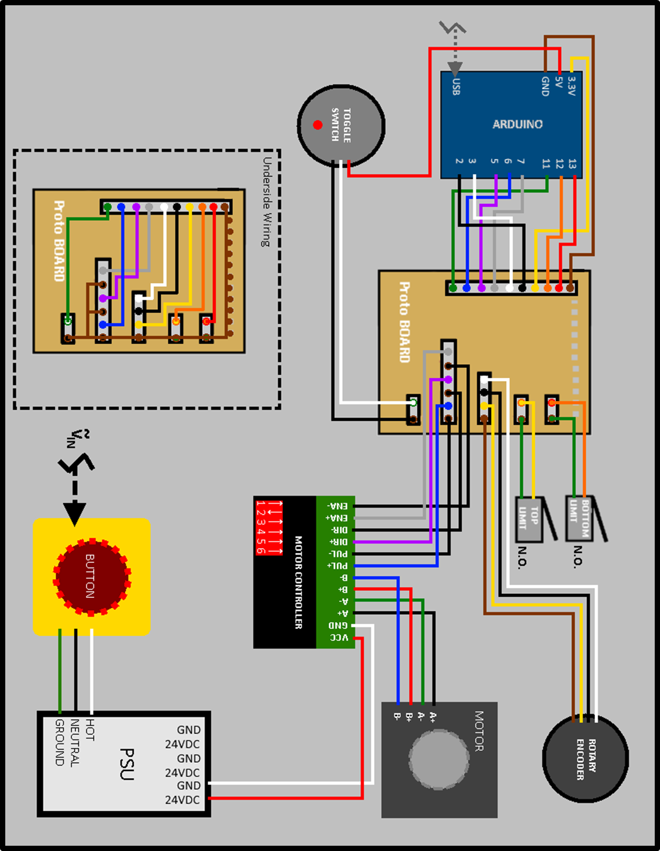

Fig 14.d

1. Switch Triggering
   1. Manually move wedge to top limit {Fig 15.a}
   2. Listen for top switch to click crisply
   3. Manually move wedge to bottom limit {Fig 15.b}
   4. Listen for bottom switch to click crisply

|  |  |
| --- | --- |
| Fig 15.a | Fig 15.b |

1. Panic Button
   1. Plug in wavemaker
   2. Twist panic button {Fig 16.a}
   3. Check that the wedge cannot be easily moved manually
   4. Press panic button firmly {Fig 16.a}
   5. After brief delay ensure wedge can now move freely
   6. If wedge remains firmly in place after panic switch is pressed do not operate wavemaker

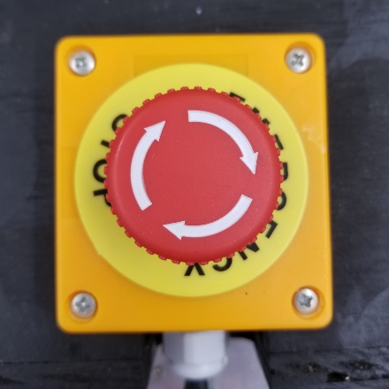

Fig 16.a

**Weekly Maintenance**

Remove wavemaker from tank prior to maintenance

1. Recoating Wedge [TREAT WEDGE]:
   1. Spray light coat of white lithium grease onto a paper towel {Fig 17.a}
   2. Wipe paper towel over wedge surface
   3. Buff wedge surface with paper towel until grease splotches are no longer visible

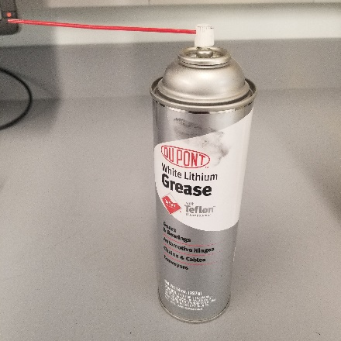

Fig 17.a

1. Cleaning Water [CLEAN WATER]:

Note: Only compete as needed

* 1. Drain old water from tank
  2. Refill with new water
  3. Add treatment media

1. Lubricating Rails and Axels [LUBRICATE RAILS & AXLES]
   1. Ensure wavemaker is powered off
   2. Move wedge to bottom limit
   3. Spray light coat of white lithium grease into rails above wedge
   4. Move wedge to top limit
   5. Spray light coat of white lithium grease into rails below wedge
   6. Use excess to gently lubricate top and bottom axle bearing points

|  |  |  |
| --- | --- | --- |
| Fig 18.a | Fig 18.b | Fig 18.c |
| Fig 18.d |  |  |

1. Checking Wedge Seal [CHECK WEDGE SEAL]
   1. Check that wingnuts inside wedge are finger-tight
   2. Ensure O-rings are properly squished
   3. Check for any cracks in wedge acrylic
      1. If cracked, flood crack with solvent weld and allow to dry for 12 hours. If crack still leaks, coat crack with gel based super glue and allow to cure.

|  |  |
| --- | --- |
| Fig 19.a | Fig19.b |

**Monthly Maintenance:**

Remove wavemaker from tank prior to maintenance

1. Check Fasteners are Tight [CHECK ALL FASTENERS]
   1. Use 5/32 Allen to ensure all frame brackets are tight
   2. Use 5/32 Allen to ensure axle bearings are right
   3. Use fingers to gently ensure wedge fasteners are all tight
   4. Use 7/16 socket to ensure electronics sled is tight
   5. Use 3mm Allen to ensure motor bracket is tight
   6. Use Philips screwdriver to ensure limit brackets are tight
2. Check Rail Parallel [CHECK RAIL PARALLEL]
   1. Use calipers to measure top rail spacing {Fig20.a}
   2. Use calipers to measure bottom rail spacing {Fig 20.a}
   3. If necessary, loosen frame brace wingnuts and adjust top/bottom spacing

{Fig 20.b&c}

* 1. Repeat until rails are parallel

|  |  |  |
| --- | --- | --- |
| Fig 20.a | Fig 20.b | Fig 20.c |

**`**

1. Cleaning Belt and Idlers [CLEAN BELT & IDLERS]
   1. Loosen black idler
   2. Disengage belt from pulleys
   3. Use damp towelette to wipe down pulley
   4. Wipe down pulleys and idlers {Fig 20.a}
   5. Reengage belt
   6. Tension Belt

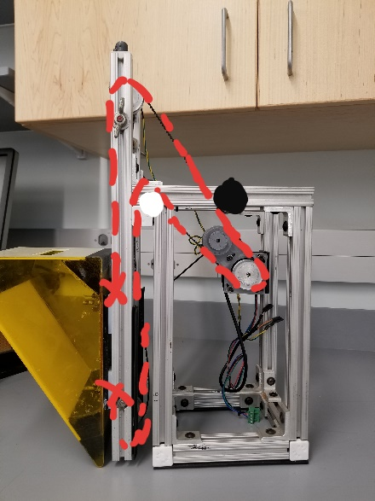

Fig 21.a

1. Check for Wear [CHECK PARTS FOR WEAR] {Fig 22.a,b,c,&d}
   1. Check linear slides, lower limit trigger, idlers, and encoder pulley

|  |  |  |
| --- | --- | --- |
| Fig 22.a | Fig 22.b | Fig 22.c |

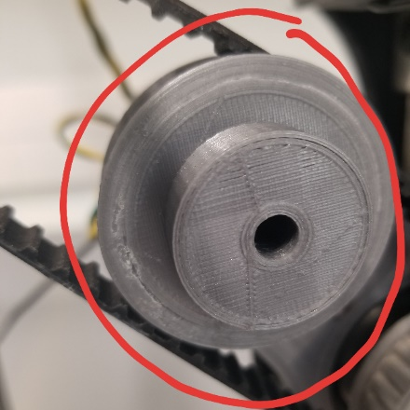

Fig 22.d

**Pre-Lab Shutdown Maintenance:**

1. Remove Tension from Belt [SLACKEN BELT]
   1. Loosen black idler {Fig 23.a}
   2. Ensure belt is loose

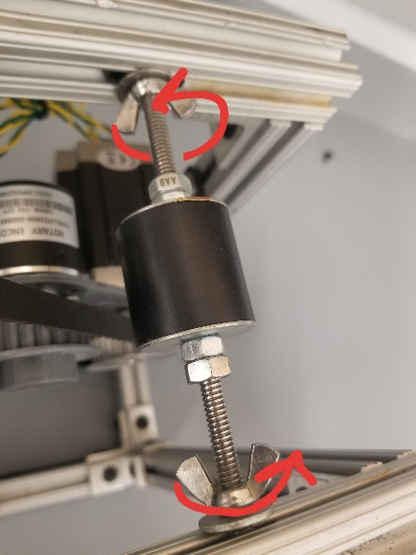

Fig 22.a

1. Dry and Store Wavemaker [DRY & STORE]
   1. Use paper towels to wide standing water from wavemaker surface
   2. If available use pressurized air to dry thoroughly
   3. Depress panic button
   4. If necessary, remove wedge
      1. Loosen wingnuts inside wedge completely
      2. Pull wedge from sled
      3. Place all loose hardware inside a zip-lock inside the wedge
      4. Ensure no O-rings have been misplaced
   5. Coil cord loosely around frame
   6. Store in upright position do not store resting on wedge or power supply unit

**Future Features:**

A place to track future feature ideas and needs

**Time Series Rotary Encoder Data**

The ability to output the rotary encoder time series date to an array would be beneficial for experiment precision. This could be achieved through an interrupt handler(?). Or more directly by creating a master slave setup between the Arduino UNO and a Raspberry PI.

**Improved Microcontroller**

A faster microcontroller would allow for a broader spectrum of movement speeds. Currently the minimum period is directly proportional to the amplitude of movement. With a faster microcontroller the max step speed wouldn’t be hindered on a firmware side. An Arduino DUE would be optimal, however, with enough pain and suffering, the same thing could be done with a Raspberry Pi.

**Freeform Movement Input**

Consider only after upgrading the microcontroller. It may be possible to take a signal generator input in as an analog input and interpret that waveform as a position vs time function. Using that interpreted signal software could mimic the movement. This upgrade to the hardware and code would essentially allow for much more complicated waveforms than just sinusoids.

**Upper Limit Overhaul**

Would be a good idea to slightly modify the upper limit so it triggers off the sled, not the wedge. This would allow different wedges to be hot swapped without need to redo the limit calibration every time.